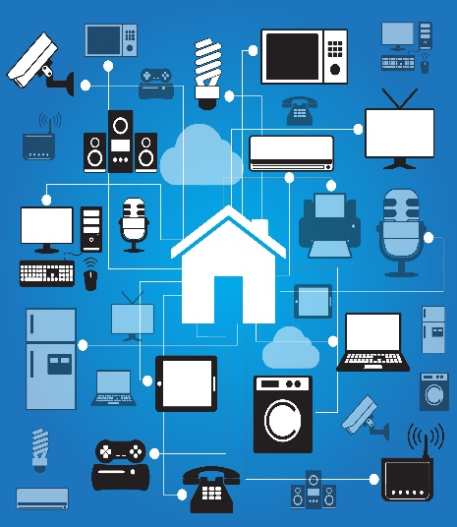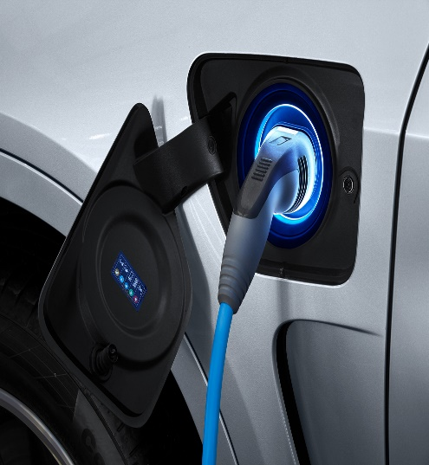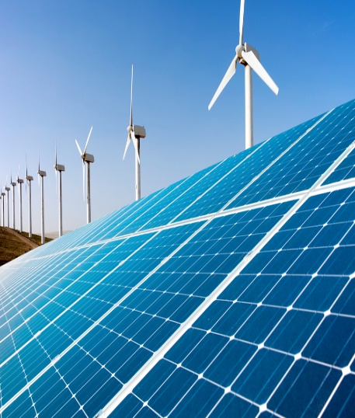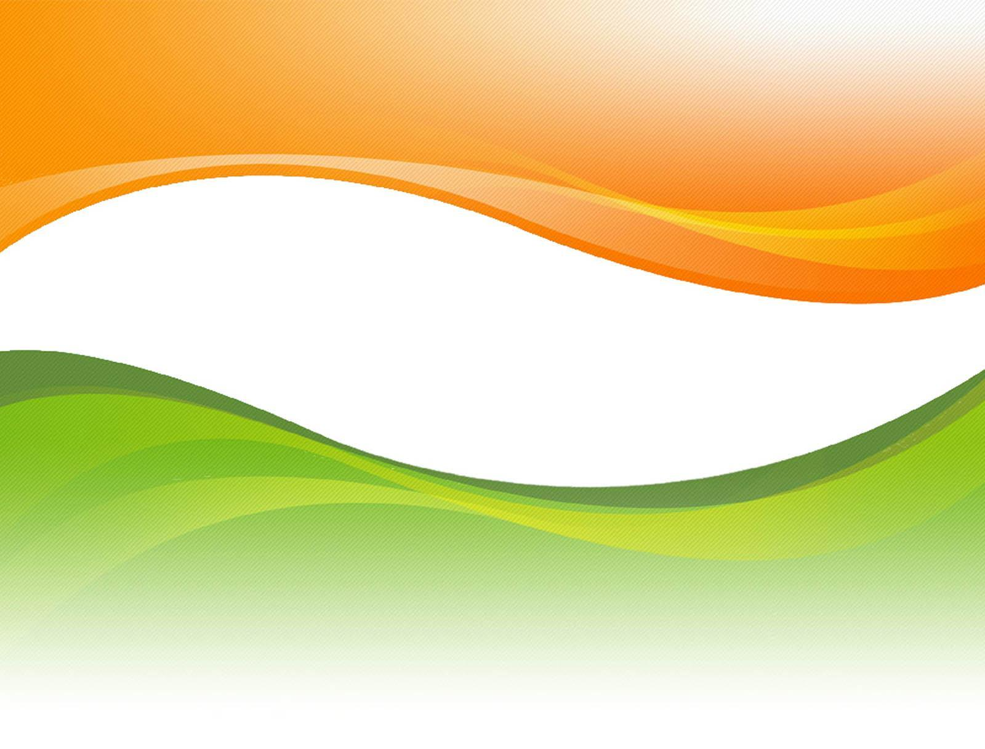
Department of Science and Technology
Ministry of Science and Technology
Government of India

Off Grid Access to Electricity Innovation Challenge IC 2

1-2 March 2019
IIT Delhi, New Delhi

*To be confirmed

Off Grid Access to Electricity Innovation Challenge

1-2 March 2019
IIT Delhi, New Delhi

Knowledge Partners
Indian institute of Technology, Delhi
Delhi Technological University, Delhi

Organized by

About the Meeting

Introduction

Second International Meeting on Off grid access to electricity Innovation Challenge during March 1-2 March 2019 in New Delhi, India, aims to bring together leaders and visionaries from government, scientific community, and the private sector that are looking at the entire value chain in a holistic way and can speak about and debate the development of these complex changes, which are redefining the future of energy worldwide. The 2-days event at New Delhi, India is intended to become a must-attend event for the Energy Experts to identify and pursue RD & D pathways for provide off grid solution for betterment of people living in marginal conditions.

Main objective of the Meeting

Building upon the Stakeholder Workshop: Identifying Technology Innovation Needs and Opportunities under Mission Innovation Challenge no#2: Off-grid Access to Electricity event at Paris City on 12th July 2017, the present meeting aims to facilitate an informed expert dialogue that assists in bridging the knowledge gaps in key area and also to better understand the linkages of elements to provide solution to off grid households and communities. The meeting will focus on achieving the following objectives:

- Build an improved, shared understanding of the state of technologies evolve out to provide reliable solution to off grid households and communities
- Promote collaboration opportunities to researchers, innovators, and potential investors;
- Develop new collaboration projects between key partners (government-to-government, researcher-to-researcher, public-private, etc.) in order to work forward to business model
- Inspire the decision makers and leaders around the world and showcase the possibilities and benefits that can be generated from bringing together the top minds in science and industry and from working together on finding solutions for marginal households.

Course of Events

The 2-days event will consist of plenary sessions, thematic panel and group discussion. An exhibition will be held in conjunction with the meeting.

Participants

- Representatives of Mission Innovation countries Innovation Challenge 2: Off Grid Access to Electricity .
- Australia
- Brazil
- Canada
- China
- European Union (Represented through European Commission)
- Finland
- France
- Germany
- India
- Indonesia
- Italy
- Mexico
- Morocco
- Netherland
- Norway
- Republic of Korea
- Saudi Arabia
- Sweden
- United Kingdom
- United States of America

- International Agencies: IEA, IRENA, WEF, UNIDO, SE4ALL, ADB, ISA, RMI, ADB

- Stakeholders, such as policy makers, senior advisors, technical experts, industry representatives, financial institutions and investors.

- Broader public and think tanks.

PROGRAMME
Second International Stakeholders Meet on Mission Innovation Challenge IC2:
Off Grid Access to Electricity

Friday, 1 March 2019

09:00–09:30 | Registration
09:30-10:00 | Inaugural session : Setting the Scene
 | Welcome Address | Dr. Sanjay Bajpai,  Head, TMD (E&W), DST
 | Opening Remarks | Prof. V. Ramgopal Rao  Director, IIT Delhi
 | Introduction to MI challenge IC2 | France (Co-lead)
 | Keynote Address | Shri Upendra Tripathy, DG-International Solar Alliance (tbc)
 | Inaugural address | Dr. Renu Swarup, Secretary, DBT (tbc)
 | Vote of thanks | Shri Vineet Saini, Scientist -E , DST
10:00-10:45 | Group Photo, High Tea, Poster session and Exhibition on off grid innovations
10:45-13:30 | Technical Session-I  Mission Innovation Session  MI countries & Perspective of International organization
13:30- 14:30 | Lunch
14:30-16:00 | Technical Session-II  Success stories and Initiatives in Off Grid Solution in France, India and other MI Countries
16:00-16:15 | Tea-Coffee break
16:15- 17:30 | Panel Discussion  Way forward to accelerate deployment of Off Grid solution  Chair: Prof. Ashutosh Sharma, Secretary, Department of Science and Technology  Co-Chair: Prof. V. Ramgopal Rao, Director, IIT Delhi
17:15- 18:00 | High Tea

Saturday, 2 March 2019

9:30- 11:00 | Overview of MI Projects : Off Grid access to Electricity in France  Overview of MI Projects : Off Grid access to Electricity in India  Overview of MI Projects : Off Grid access to Electricity in MI Countries  Detailed presentation of Ongoing MI projects in India ( 4 projects)
11:00- 11:15 | Coffee Break
11:15-12:30 | Detailed presentation of ongoing MI Projects : Off Grid access to  Electricity (5 Projects)
12:30-13:00 | Concluding Session  Conclusion Remarks & Next Steps by Sanjay Bajpai and France co-leads  Vote of thanks by Vineet Saini

